O'ZBEKISTON RESPUBLIKASI HARBIY XAVFSIZLIK VA MUDOFAA UNIVERSITETINING
AXBOROT-KOMMUNIKATSIYA TEXNOLOGIYALARI VA HARBIY ALOQA INSTITUTI


Sun’iy intelekt asoslari fanidan

2-TOPSHIRIQ

Guruhi: 4/10-22
Bajardi : Kursant Norov Beksulton
Tekshirdi : Kapitan Isakov Muhriddin

Toshkent – 2025

1-topshiriq:
n ta talabaning baholari (0 dan 100 gacha) ro‘yxatga kiritilgan. Dastur:
- bahosi 60 dan yuqori bo‘lgan talabalarning sonini;
- bahosi 60 dan past bo‘lgan talabalarning sonini alohida hisoblab chiqsin va ekranga chiqarsin.
Topshiriq javobi:
talabalar = int(input("Talabalarni kiriting sonini kiriting: "))
ruyxat = []
past=0
yuqori=0
for i in range(talabalar):
son = int(input(f"{i+1} - talabani bahosini kiriting: "))
ruyxat.append(son)
if ruyxat[i] >= 60:
yuqori+=1
else:
past+=1
print("Yuqori baho olgan talabalar soni: ", yuqori,end="\n")
print("Past baho olagan talabalar soni: ", past )
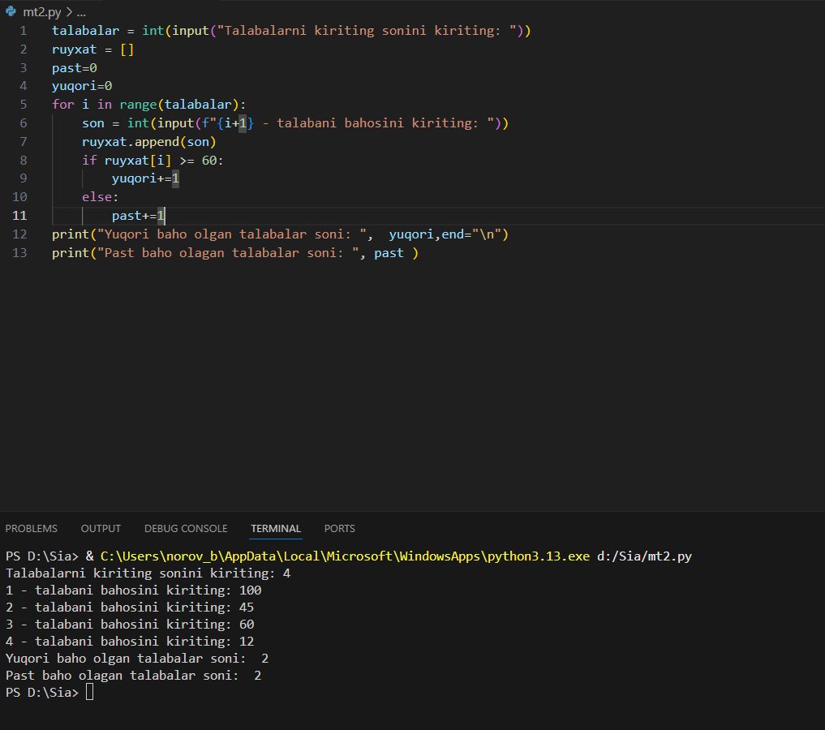
2-topshiriq:
Baholar ro‘yxati berilgan. Dastur:
- baholarni quyidagi toifalarga ajratib chiqsın:
  - 0–54: “Qoniqarsiz”
  - 55–70: “Qoniqarli”
  - 71–85: “Yaxshi”
  - 86–100: “A’lo”
- har bir toifa uchun nechta talaba tushishini hisoblab, natijani chiroyli ko‘rinishda (jadvalga o‘xshash) ekranga chiqarsin.
ruyxat = [45,50,20,15,70,90,99,87,59,63,55,78,81]
toifa_1=[]
toifa_2=[]
toifa_3=[]
toifa_4=[]
for i in ruyxat:
if i > 0 and i<=54:
toifa_1.append(i)
elif i > 54 and i<=70:
toifa_2.append(i)
elif i > 70 and i<=85:
toifa_3.append(i)
elif i > 85 and i<=100:
toifa_4.append(i)
print("Birinchi toifa", toifa_1)
print("Ikkinchi toifa", toifa_2)
print("Uchinchi toifa", toifa_3)
print("To'rtinchi toifa", toifa_4)
